**“YingXao” Automatic EcoGardener**

ECE4871 Senior Design Project

**Team Name**

Shouku

**Project Faculty Advisor**

Dr. Linda Milor

**Team Members**

Yilun Chen, CmpE, [allenchen@gatech.edu](mailto:allenchen@gatech.edu)

Yida Wang, CmpE, [yida@gatech.edu](mailto:yida@gatech.edu)

Yihan Jiang, CmpE, [yjiang400@gatech.edu](mailto:yjiang400@gatech.edu)

Xi Li, EE, [xli832@gatech.edu](mailto:xli832@gatech.edu)

Submitted

11-13-2020

# **Table of Contents**

**Executive Summary** **4**

**1. Introduction** **5**

1.1 Motivations 5

1.2 Objectives 5

**2. Project Description, Customer Requirements, and Goals** **7**

**3. Technical Specifications** **9**

3.1 Microcontroller 9

3.2 Humidity Sensor 9

3.3 Light Sensor 10

3.4 Planter Nursery Pot 10

3.5 Rechargeable cells 11

3.6 Light Shield 11

**4. Design Approach and Details** **12**

4.1 Design Approach 13

4.1.1 Sensing 13

4.1.2 Control 13

4.1.3 Communication 13

4.2 Design Concept Ideation, Constraints, Alternatives, and Tradeoffs 14

4.3 Preliminary Concept Selection and Justification 15

4.3.1 Currently Known Concepts 15

4.3.2 Concepts To Be Finalized 16

4.3.3 Concepts Yet To Be Figured Out 16

4.4 Engineering Analyses and Experiments 17

4.5 Codes and Standards 18

**5. Project Demonstration** **19**

**6. Schedule, Tasks, and Milestones:** **20**

6.1 Tasks 20

6.2 Schedule / Gantt Chart 21

**7. Marketing and Cost Analysis** **22**

7.1 Marketing Analysis 22

7.2 Cost Analysis 23

**8. Current Status** **26**

**9. Leadership Roles** **26**

**10. References** **27**

# Executive Summary

To help people in fast-paced urban life to have their indoor plants without spending time on taking care and acquiring relative skills, YingXao is a smart gardening solution that takes care of any arbitrary plant specified by the user.

We’re looking for $500 funding for R&D of the project. After we have a working prototype we can start to mass produce our products. Expected profit of the first fiscal year going into mass production is projected to be $25,900, with $191,360, $169,632 and $113,088 projected for the years that follow.

The design of YingXao consists of two parts. The first part focuses on building the software-hardware ecosystem of the EcoGardener. A microcontroller will be used in orchestrating the system, deciding on the amount of water, sunshine, and nutrition used in the gardening plan. The other part is the visualization and adjustment of the plant status on an app. Users will be able to select a desired mode for the plant and make modifications to specific elements for the gardening plan.

The EcoGardener hardware costs 100$ per unit. We will provide more software OTA upgrades plans after the one-time purchase, which includes support for more species of plants, more efficient plant management, etc.

The solution will be determined to be effective if:

1. The system can proactively react to the environment and user specifications and adjust its gardening approach accordingly.

2. The user trusts the system to take care of the plants.

3. The user is willing to occasionally add supplies (water, fertilizers, etc) to the system.

OTA-ready architecture allows us to exploit the potential of such a setup. Therefore, future work on the project includes and is not limited to: Constantly improving the gardening plans for certain plant species, providing users with more user-friendly interfaces, etc.

**“YingXao” Automatic EcoGardener**

Team Shouku is requesting $300 amount of funding from the senior design lab to develop YingXao (mainly used in hardware prototyping devices).

# **1. Introduction**

### 1.1 Motivations

In modern cities, people in fast-paced life don’t have enough time to take care of their indoor plants or don’t have the necessary skills to take care of their plants. However, it’s still important to have indoor plants for human beings because indoor plants can improve the air quality by exchanging oxygen with other gases humans produce with breathing, like carbon dioxide. Also, some research shows that indoor green plants can reduce the chance of getting mental illness and that looking at green plants can help humans maintain healthy eyesight. With all consideration above, team Shouku attempts to provide people with a new option, YingXao the Automatic EcoGardener, that automatically takes care of the user's plants. The only thing users need to do is to enjoy their easy green life.

### 1.2 Objectives

Aimed users of EcoGardener are people who are buried with their work and have no extra free time to take care of their plants. To make it work, EcoGardener should be placed under sunshine and near a wall plug. EcoGardener can control light exposure, water supply, and external chemical input. EcoGardener has motors and a glass shield attached for sunlight input control. The motor will adjust the angle of the glass shield to block sunlight or reflect sunlight, either reducing or increasing the amount of sunshine that the plant is exposed to. For water control, a humidity sensor, a water pump, and a water tank will be embedded in the pot. The water tank is at the bottom of EcoGardener so that after the humidity sensor sends signals to the water pump and pumps water, excessive water will be recycled by the water tank to save water. To provide enough nutrients, EcoGardener will send messages to users and inform users which kind of mineral nutrient is required for their specific kinds of plants. The EcoGardener communicates with users and remote databases via Wi-Fi.

The remaining of this document will further specify the following aspects of this project: description and goals of the EcoGardener project, relative technical specification, design approach and details, tasks and schedule, cost analysis, demonstration of the project, current status, and leadership roles.

### 1.3 Competition

We expect to have competitions with existing smart-garden products in the market. However, the customers that we are targeting are slightly different from the target customers of existing products. We offer low-cost robust smart home gardening devices, distinguishing our product from industrial-scale smart farming, or luxurious home smart gardening.

With attractive pricing, robust design and rich features, we expect to occupy a solid share of the smart gardening market.

# **2. Project Description, Customer Requirements, and Goals**

The overall project is orchestrated by a microprocessor, which is responsible for parsing sensor data, sending control signals, and communicating with the cloud database.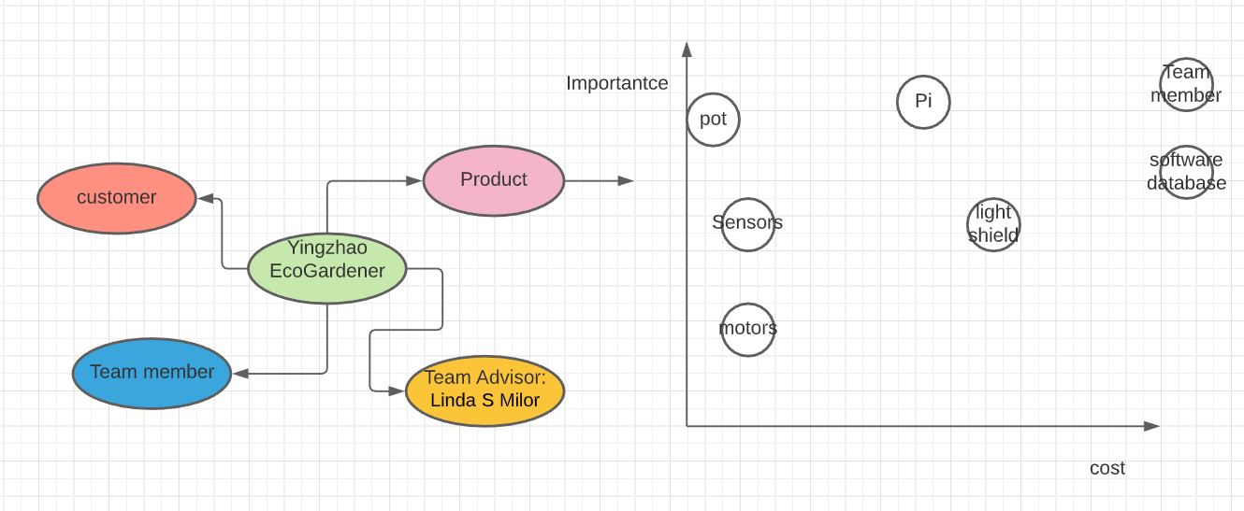

**Figure 1.** Stakeholder graph and Stakeholder 2x2 chart.

**Customer requirements:**

1. Lower electricity consumption
2. High autonomy
3. High portability
4. Cheap

**Goals:**

1. The final product should completely free customers from taking care of plants. Customers only need to instruct YingXao what plants they want to grow. The final product should be able to consume less energy and provide users with as much autonomy as possible. Customers can completely leave the plants to the YingXao. YingXao would have high portability so that an adult can carry it by one hand.
2. Target users are someone who has no time to take care of indoor plants, but they are still willing to decorate their living environment with plants.
3. The Target price is $100.

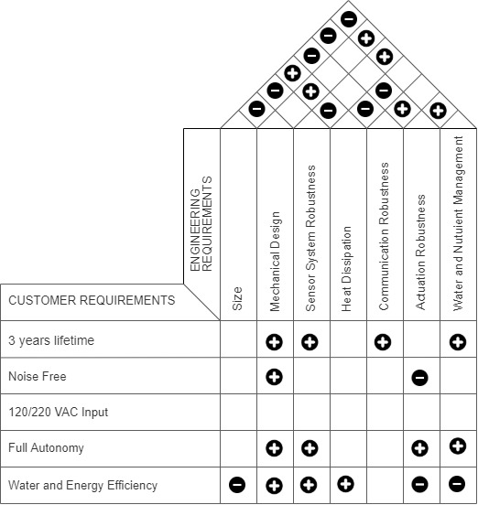

**Figure 2.** Quality Function Deployment (QFD) of YingXao EcoGardener.

From QFD table above, the design of Yingzhao has conflicts between water and energy efficiency and adoration robustness, heat dissipation and communication robustness. Better mechanical design can contribute to heat dissipation and noise reduction.

# **3. Technical Specifications**

### 3.1 Microcontroller

**Table 1** contains the performance specification for the Raspberry Pi Zero W.



### 3.2 Humidity Sensor

**Table 2** contains the specification for the humidity sensor.



### 3.3 Light Sensor

**Table 3** contains the specification for the PIR sensor.



### 3.4 Planter Nursery Pot

**Table 4** contains the specification for the nursery pot.



#### 

### 3.5 Rechargeable cells

**Table 5** contains the specification for the rechargeable battery.



### 3.6 Light Shield

**Table 6** contains the specification for the light shield.



The overall system performance specification is mainly determined by the microcontroller because it represents the brain of the system. The microcontroller is connected to all the sensors to receive necessary data from the plant, and it is also sending the data to the database to notify the user when it is needed. The user can issue different commands through our mobile app based on the type of the plant. For example, the user can choose to manually add water to the plant or control the sunlight cover. All of these features will be determined by how fast the microcontroller is processing the data and communicating with the sensors and database.

# 

# **4. Design Approach and Details**

There are three main components of EcoGardener: Sensing that acquires environment data and sent to the microcontroller, Controls that reacts to the environment, dynamically adjusting the systems’ gardening strategy, and Communication that takes care of the system’s interaction with our cloud infrastructure.

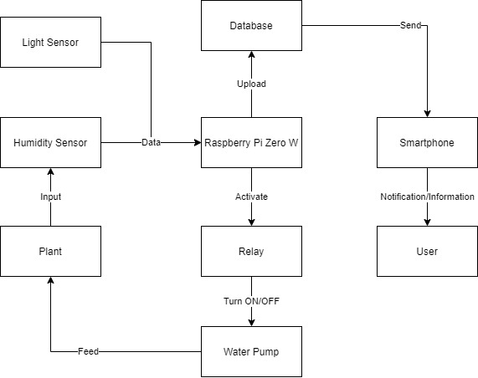

**Figure 3.** System overview block diagram of YingXao EcoGardener.

### 

### 4.1 Design Approach

#### 4.1.1 Sensing

Light sensor, and humidity/temperature sensor, and potentially more sensors will be installed onto the board to acquire environment data.

#### 4.1.2 Control

Control actuators include 2 motors and 1 water pump.

The 2 motors are responsible for controlling the movement of the light shield, and the water pump will be responsible for controlling water ingestion into the pot.

#### 4.1.3 Communication

YingXao communicates with remote databases to get the optimal strategy for growing the plant specified by the user by making RESTful API calls to the server, while also submitting its sensor data to the cloud infrastructure to process.

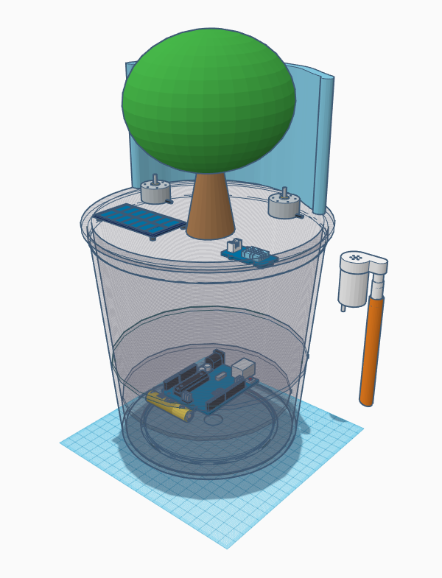

**Figure 4.** Conceptual 3D model of YingXao EcoGardener.

### 4.2 Design Concept Ideation, Constraints, Alternatives, and Tradeoffs

Realistic design constraints

1. Power consumption
2. Size and cost of battery: the solar panel is environment-friendly but relatively expensive for a vase. It is important to choose a cheaper one, such as the lithium battery.
3. Glass filter for sunlight: we need to carefully choose the color of the outside cover to accommodate the individual sunlight requirements of plants.

Trade-offs

1. Higher prices will make projects more effective but less attractive to potential customers.
2. More powerful MCU’s (Like Raspberry) provide additional functionalities and potentials for OTA upgrades but are more power-hungry and costly.

Hardware-software trade-offs, interfaces, and/or interactions

* The MCU reads data from environmental sensors.
* The MCU controls actuators to adjust humidity levels/luminosity levels, etc.
* The MCU pulls data from a remote database.
* The MCU hosts a web page as a UI.
* The MCU supports sleep mode for low power.
* The MCU uses RTOS.

### 4.3 Preliminary Concept Selection and Justification

#### 4.3.1 Currently Known Concepts

1. We will set up a set of cloud-based infrastructure as a centralized space to store and distribute gardening strategies. We decided to go with a cloud-based approach because it unlocks the potentials for future OTA updates, allowing our already-sold products to constantly improve themselves, instead of being static after we deliver the product.
2. We will create a mobile app for users to monitor the status of the system. This is because although we want the system to be self-contained and fully autonomous, it is still important for the user to have insights on how the plant is doing, and be notified when there is emergency manual work required for the system.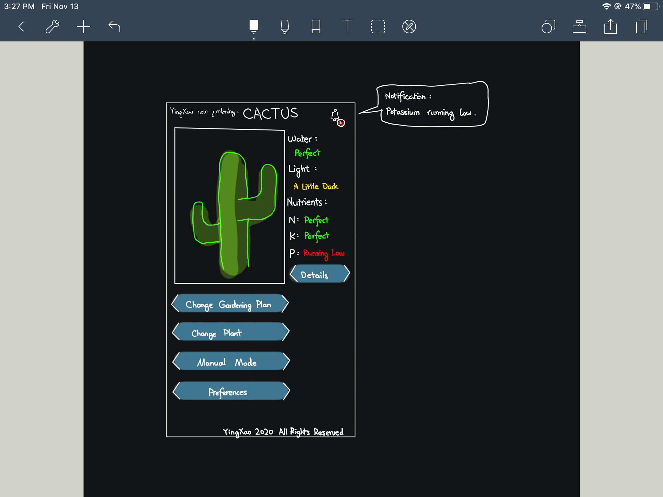

**Figure 5.** Conceptual design of the mobile app interface.

1. We will have a water tank below the soil to collect excess water pumped into the soil. This allows us to conserve water and it was proven that reused water doesn’t affect the growth of the plants.

#### 4.3.2 Concepts To Be Finalized

1. We’re still in a hot discussion of whether to collect the user’s plant data or not. On one hand, we want to protect clients’ (and their plants’) privacy, but that data, if collected in large quantity, can provide us invaluable insights on how to improve our gardening algorithms, allowing us to iterate on our gardening strategies more quickly, and in turns giving our clients better experiences with YingXao.
2. We still need to define the specific scope of the app - what we want it to be able to do and what it shouldn’t be able to do. One of the things that we are discussing is whether to allow users to manually modify the gardening strategy - We want to let users have full control of the system, but an uninformed adjustment to the strategy might end up damaging or even killing the plant.
3. We need to decide on how different parts of the project communicate with each other, especially with the database. For now, the most ideal solution seems to be establishing a server and exposing RESTful APIs, but we do need to take security, speed, bandwidth, and other factors into consideration.

#### 4.3.3 Concepts Yet To Be Figured Out

1. (CRITICAL) We still need to figure out how to adjust lighting for the system. For example, on a cloudy day, the amount of light we can provide is extremely limited. If we decide to use artificial lights to compensate for it, it will dramatically increase the cost of the product.
2. We need to figure out a way to let users have easy access to the nutrient packages that the YingXao system needs to take care of the plants. This requires a well-established supply chain since the packages are probably too small to be worth shipping packages for.

### 4.4 Engineering Analyses and Experiments

We will conduct separate tests for all individual components of the system, followed by a series of system-wide integration tests.

Communication tests:

1. Robustness: When transmitting data packages from/to the database in large quantities (>1M packages), no package is dropped.
2. Speed: Transmission from/to database takes no longer than 1 second even with high traffic (>1000 data packages per second).
3. Fail-safe: When timed out / internet not available, the system will cache the information and retry afterward.

Actuation tests:

1. Light control tests: We will prepare two virtual plants that one needs no sunlight at all and the other always needs sunlight. After the corresponding gardening plans are pulled from the database, YingXao will be rotated by hands. YingXao should be able to adjust the light shield to decrease or increase the amount of light exposure(one virtual plant doesn’t need light whereas the other needs full exposure) within 5 seconds.
2. Water pump tests: We will prepare a virtual plant that requires 20ml water every 1mins. After the corresponding gardening plans are pulled from the database, the pumped water will be collected every minute and measured. the volume of the water collected should be no more/less than 20ml ± 0.5ml.

### 4.5 Codes and Standards

* Institute of Electrical and Electronics Engineers (IEEE)
* Coordinated with ANSI, ETSI, and other standards organizations (e.g. IEEE/ANSI N42)
* IEEE 802.xx standards are most cited and concentrate on telecommunications
* IEEE 1666 standards concentration on software
* Environmental Protection Agency (EPA)
* Occupational Safety and Health Administration (OSHA)
* Consumer Product Safety Commission (CPSC)

Comm

# **5. Project Demonstration**

Our demonstration will focus on both the vase itself and the app that can monitor the environment of the vase and modify the vase setting. The project will be presented through a combination of pre-made posters and a live demonstration.

The pre-made poster will mainly be a high-level overview along with some decision-making process as we worked on this project. The big picture of the design will be demonstrated by a PERT chart. We will present some existing automatic gardeners on the market and point out our strengths compared to them, as well as the challenges we faced during the design process and some possibilities to improve the product in the future.

The live demonstration will focus on the functionality of YingXao. We will present how YingXao automatically adjusts its gardening strategy in response to changes in the environment as well as user specifications. The monitoring app will show the temperature, humidity, and luminosity data and allows users to manually change the vase settings. The detailed demonstration steps are listed as follows:

1. Open the YingXao app and select a plant seed that will be put in YingXao.
2. Show audiences the initial settings and the movement of motors inside YingXao.
3. Present the current environmental data on the app.
4. Drain the water to trigger the watering and fertilizing functionality, and show the corresponding update on the app.
5. Move YingXao to a sunny area to trigger the shielding functionality, and show the corresponding update on the app.
6. Manually change settings on the app and present the changes in the YingXao environment.

# **6. Schedule, Tasks, and Milestones:**

The development cycle of YingXao is divided up into tasks and their corresponding sub-tasks. Task leaders will be in charge of managing and pushing the task forward while the assignees of individual sub-tasks will be in charge of finishing these tasks.

Example:

1. This is a task (task leader)
   1. Sub-task 1 (assignee)

### 6.1 Tasks

1. **Prep Work and Procurement (Xi Li)**
   1. Finalize Project Proposal (Yilun Chen)
   2. Purchase prototyping devices / parts (Xi Li)
2. **Parts Testing (Yida Wang)**
   1. Sensors tests (Yida Wang)
   2. Microcontroller tests (Yida Wang)
   3. Actuators tests (Xi Li)
3. **Sensor Integration with Microcontroller (Yida Wang)**
   1. Firmware development (Yida Wang)
   2. Sensor Integration (Xi Li)
   3. Sensor Integration tests (Xi Li)
4. **Pot Design (Yida Wang)**
   1. CAD design of the physical pot (Yida Wang)
5. **Database and App Design (Yihan Jiang)**
   1. Database setup and API Exposure (Yilun Chen)
   2. App Design (Yihan Jiang)
   3. App Integration with the database (Yihan Jiang)
   4. App Integration with microcontroller (Yihan Jiang)
6. **Presentation / Demo Material Preparation (Yilun Chen)**
   1. Presentation slides design (Yilun Chen)
   2. Flyers design (Yilun Chen)
7. **System Testing and Evaluation (Xi Li)**
   1. System-level integration test (Xi Li)
   2. System Optimization (Yilun Chen)
8. **System Finalization (Xi Li)**
   1. Review evaluation result (Xi Li)
   2. Further improve robustness (Yida Wang)
9. **Add-on Features (Xi Li)**
   1. TBD (TBD)
10. **Presentation / Demo Preparation (Yilun Chen)**
    1. Finalize presentation materials (Yilun Chen)
    2. Coordinate Rehearsals (Yihan Jiang)

### 6.2 Schedule / Gantt Chart

The Gantt chart of the tentative schedule is in Appendix A. It lists the start and the end date of the ten tasks in section 6.1. The development cycle begins at the first meeting of ECE 4872 in the next semester and ends one week before the demonstration date. The length of the highlighted grids is the assigned date to each task. The critical path consists of the tasks that are colored as red.

# **7. Marketing and Cost Analysis**

### 7.1 Marketing Analysis

Plants are an essential element in a room for their decorative and practical usage. Their enjoyable appearance and the fresh air it brings increase the demand for in-door pot. The busy working or schooling schedules, however, prevent people from taking good care of the plants. By analyzing the customer reviews[7][8] under some EcoGardeners, we summarize several expectations and feedbacks of an automatic in-door gardener.

1. Customers want to see the real-time update of the environmental data on the app.
2. Large gardeners are too expensive.
3. Instructions are too complicated.
4. The light on the gardener is too bright and too hot.

YingXao meets all the expectations and improves the problems mentioned in the feedback. We create an app that can track the real-time data of the gardener environment. The price is much cheaper compared to the existing gardeners of similar sizes. The instruction has only one step, which is choosing the plant seed and all other steps will be automatic. YingXao does not contain a bright and hot light since it uses the sunlight and a shield to adjust the lightning.

The application of using microcontrollers in IoT smart vase is not common. Instead of taking care of the plants, most of the “smart vases” are only functioned to play music or change the vase body color. A few commercial smart vases are designed to take care of the plants, but the price is too high to be a household appliance for a normal family. Brand Gardyn[9] has a series of competitive smart gardener products such as the “GARDYN EXPLORER”, “GARDYN HERO”, and “GARDYN HERO PLUS”. Their prices are as high as one thousand dollars each after the discount applied. Gardyn smart gardener allows customers to choose the type of plant in their Gardener app and provides the corresponding growing solution and seeds for users. The app will notify the users when more water or nutrients are needed by monitoring the growth of the plants with sensors.[6] All growth data are recorded on the Gardyn app.

Our automatic EcoGardener YingXao will offer similar functionality as Gardyn in terms of allowing automatic adjustment to the environment and updates this information on an app. The pricing of YingXao will be far lower compared to Gardyn at around one hundred dollars, which is 1/10 of the Gardyn’s or similar products in the market. The smaller size also increases its portability and makes it far more energy-efficient.

### 7.2 Cost Analysis

The following table is an analysis of the cost and profit. As we illustrated in the technical specification section, the microcontroller is the Raspberry Pi Zero W, which is the cheapest one that meets the minimum requirement of building YingXao. The battery and sensors are a little bit expensive but they are durable and work well with the Raspberry Pi Zero W. The unit price of YingXao is $100, which is only one-eighth of the price of existing in-door gardeners with similar sizes. The deficit will only occur in the first year since the overhead is expensive and the developing process is long. Profits will be made in future years.

**Table 7.** Revenue and Cost Sheet.

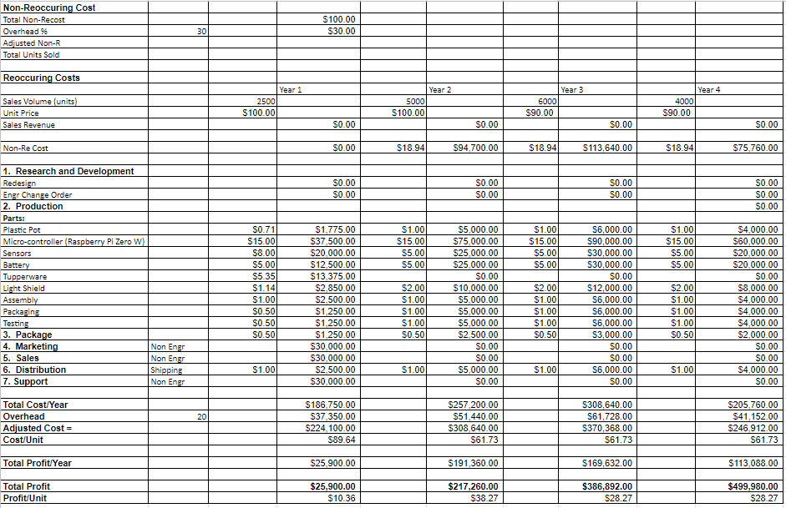

We assume the starting salaries for an engineer is 80,000 dollars per year. The development cycle of YingXao will take three months for our four engineers to finish. Thus, the total salary that needs to be paid is 80,000 dollars.

**Table 8.** Non-Reoccuring Cost.

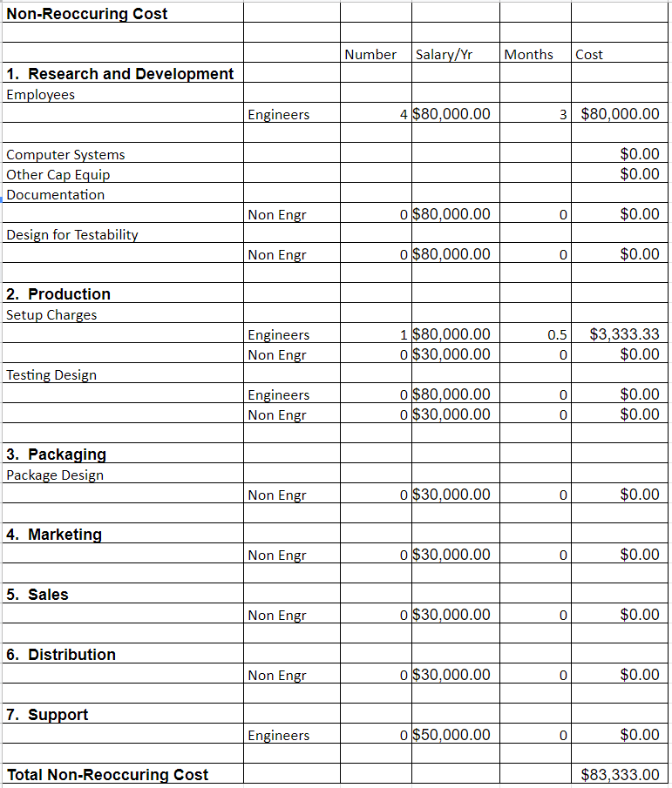

# **8. Current Status**

Our team has the skill matrix, draft project summary, and the cost analysis finished. With these assignments, we have a solid understanding of the skills of individual team members, the general design approach, and the estimated unit cost of the product. Each team member was assigned a unique role with corresponding tasks for this semester and the next semester. Yida Wang will continue to look for suitable hardware (the microcontroller and sensors) that optimizes the processing and reaction speed at a relatively low price. Xi Li will check off each step of the design process and make sure we finished everything. Yilun Chen will document the design details and update the action items on the group common page. Yihan Jiang will do more research on the best way to architect the software side of the solution and derive a plan for the app.

# **9. Leadership Roles**

**ECE 4871**

Hardware Lead: Yida Wang

Software Lead: Yihan Jiang

Project Manager: Xi Li

Documentation Coordinator: Yilun Chen

**ECE 4872**

Documentation Coordinator: Yilun Chen

Project Manager: Xi Li

Webmaster: Yida Wang

Expo Coordinator: Yihan Jiang

# **10. References**

[1] A. Prakash, "Raspberry Pi Zero W Specs, Features and More - It's FOSS", *It's FOSS*, 2020. [Online]. Available: https://itsfoss.com/raspberry-pi-zero-w/#:~:text=Raspberry%20Pi%20Zero%20W%20specifications&text=1GHz%20single%2Dcore%20ARMv6%20CPU,Micro%20USB%20power. [Accessed: 13- Nov- 2020]

[2] A. Industries, "DHT11 basic temperature-humidity sensor + extras", *Adafruit.com*, 2020. [Online]. Available: https://www.adafruit.com/product/386. [Accessed: 13- Nov- 2020]

[3] "287-18001 Mcm PIR Sensor", *Newark*, 2020. [Online]. Available: https://www.newark.com/mcm/287-18001/sensing-range-max-7m/dp/25AC5060. [Accessed: 13- Nov- 2020]

[4]"LG MJ1 10A INR 18650 Battery", *Batteryjunction.com*, 2020. [Online]. Available: https://www.batteryjunction.com/lg-mj1-inr-18650.html?gclid=CjwKCAiA-f78BRBbEiwATKRRBPDK68ubdFX9SFyl3TC2ADKP8n2jp10wMeGdB_ALp5MiYEin085LChoCyh8QAvD_BwE. [Accessed: 13- Nov- 2020]

[5] "GROWNEER 24 Packs 0.7 Gallon Flexible Nursery Pot", *Amazon.com*, 2020. [Online]. Available: https://www.amazon.com/GROWNEER-Container-Seedlings-Vegetables-Succulents/dp/B07QTJ1D3K/ref=sr_1_8?dchild=1&keywords=Plastic+Plant+Pots&qid=1602828022&sr=8-8. [Accessed: 13- Nov- 2020]

[6] "Corrugated Cardboard Filler Insert Sheet Pads", *Amazon.com*, 2020. [Online]. Available: https://www.amazon.com/Corrugated-Cardboard-Filler-Insert-Sheet/dp/B07PSL15FB. [Accessed: 13- Nov- 2020]

[7]"Click and Grow Smart Garden 3 Indoor Herb Garden", *Amazon.com*, 2020. [Online]. Available: https://www.amazon.com/Click-Grow-Smart-Garden-Indoor/dp/B01MRVMKQH. [Accessed: 13- Nov- 2020]

[8] "AeroGarden Harvest-Black Indoor Hydroponic Garden", *Amazon.com*, 2020. [Online]. Available: https://www.amazon.com/AeroGarden-901100-1200-Harvest-Black/dp/B07CKK8Z78. [Accessed: 13- Nov- 2020]

[9] "Buy Now - Gardyn", *Gardyn*, 2020. [Online]. Available: https://mygardyn.com/buy-now/. [Accessed: 13- Nov- 2020]

# **Appendix A - Project Gantt Chart**

|  |  |  |  |  |  |  |  |  |  |  |  |  |  |
| --- | --- | --- | --- | --- | --- | --- | --- | --- | --- | --- | --- | --- | --- |
|  | 01/20 | 01/27 | 02/03 | 02/10 | 02/17 | 02/24 | 03/03 | 03/10 | 03/17 | 03/24 | 03/31 | 04/07 | 04/14 |
| Prep Work and Procurement |  |  |  |  |  |  |  |  |  |  |  |  |  |
| Parts Testing |  |  |  |  |  |  |  |  |  |  |  |  |  |
| Sensor Integration with Microcontroller |  |  |  |  |  |  |  |  |  |  |  |  |  |
| Pot Design |  |  |  |  |  |  |  |  |  |  |  |  |  |
| Database and app design |  |  |  |  |  |  |  |  |  |  |  |  |  |
| Presentation / Demo Preparation |  |  |  |  |  |  |  |  |  |  |  |  |  |
| Test and evaluate YingXao |  |  |  |  |  |  |  |  |  |  |  |  |  |
| System Finalization |  |  |  |  |  |  |  |  |  |  |  |  |  |
| Add-on Features |  |  |  |  |  |  |  |  |  |  |  |  |  |
| Prepare demo and presentation |  |  |  |  |  |  |  |  |  |  |  |  |  |